<https://preschoolstem.wordpress.com/>

I introduced this week’s lesson by reading Ellen Stoll Walsh’s book, Mouse Paint, in small groups. (The book is recommended in the PEEP science curriculum‘s Color unit.) I then provided a set of three white mouse finger puppets perched atop our colored water bottles, as well as a set of color paddles for the children’s use. The actual mice stayed white, but appeared very different depending on which paddle the students looked through. It was interesting to watch them look at the mice through a colored paddle and then quickly take the paddle away to check that the mouse was, indeed, still really white.

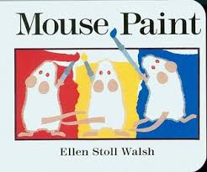

Another activity extension involved the children using our new transparent blocks for building. They quickly made the connection between these blocks and the color paddles and homemade goggles. I see everything red, and then yellow, said Jazlyn as she tried out different ways of looking through her building.

.[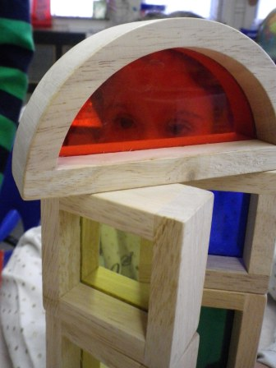](https://preschoolstem.files.wordpress.com/2012/03/6-jaz-transparent-blocks.jpg)

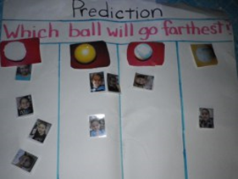

This was to be our final focused exploration and I very much wanted it to be the children’s own idea. They proposed testing which ball travels farthest. I liked that they wanted a prediction chart, which we’d used in the past. I prepared one with four columns for different types of balls. The children used it numerous times in order to run their tests. They insisted on testing EVERY ball we had!!!

<http://theimaginationtree.com/2013/08/15-discovery-box-activities-for-preschoolers.html>

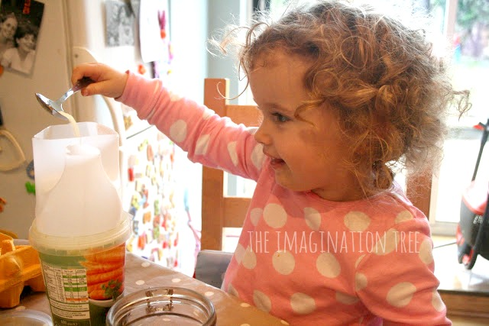

<http://www.prekinders.com/category/science/science-center/>

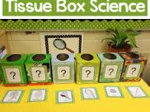

<http://www.teachpreschool.org/2014/05/ten-terrific-ways-to-get-the-most-out-of-water-play/>

